1. select avg(sal), max(sal), min(sal), sum(sal)

from emp

where job like 'SALES%';

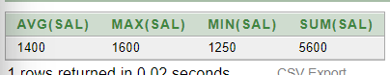

1. select min(hiredate), max(hiredate)

from emp;

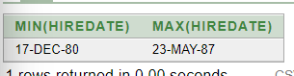

1. select count(\*)

from emp

where deptno = 30;

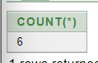

1. select count (comm)

from emp

where deptno = 30;

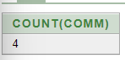

1. select avg (comm)

from emp;

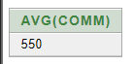

1. select avg (nvl (comm, 0))

from emp;

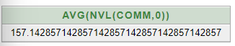

1. select deptno, avg(sal)

from emp

group by deptno;

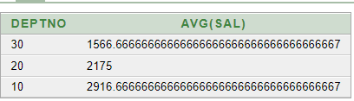

1. select avg(sal)

from emp

group by deptno;

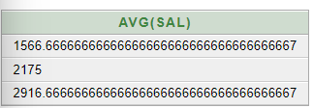

1. select deptno, max(sal)

from emp

group by deptno

having max(sal) > 2900;

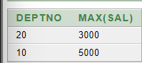

1. select job, sum(sal) PAYROLL

from emp

where job not like 'SALES%'

group by job

having sum(sal) > 5000

order by sum (sal);

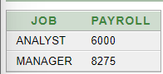

1. select max(avg(sal))

from emp

group by deptno;

